Week 8

Thanh Minh

Step 1:

1. Graphical user interface, text, application

   Description automatically generated
2. 
3. 
4. Graphical user interface, text, application, email

   Description automatically generated

**Step 2:**

1. 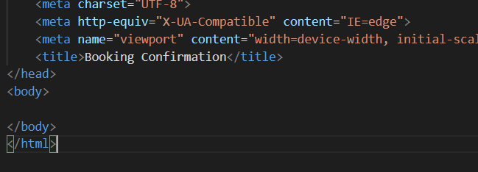
2. 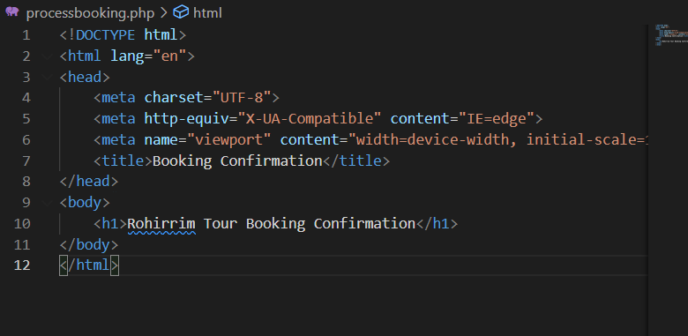

**Step 3:**

1. 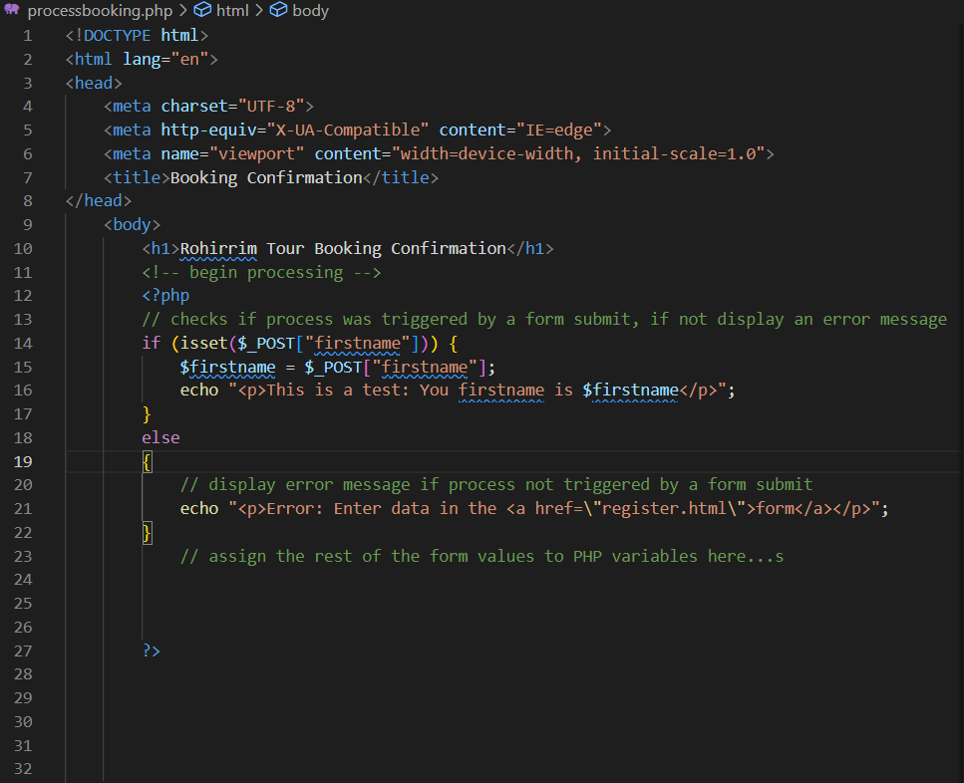
2. Graphical user interface, text, application

   Description automatically generated
3. 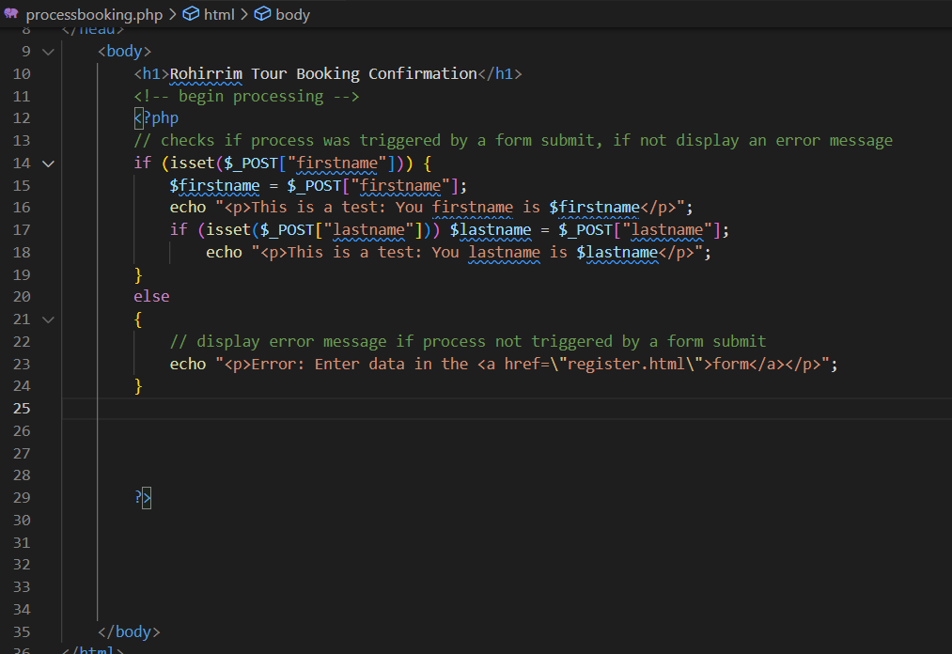
4. Graphical user interface, text, application, email

   Description automatically generated
5. A screenshot of a computer

   Description automatically generated with medium confidence

**Step 4:**

1. Text

   Description automatically generated
2. 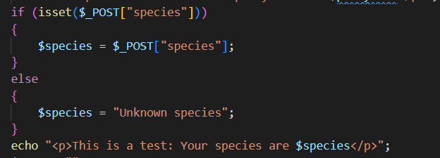
3. Graphical user interface, text

   Description automatically generated

**Step 5:**

1. Text

   Description automatically generated
2. 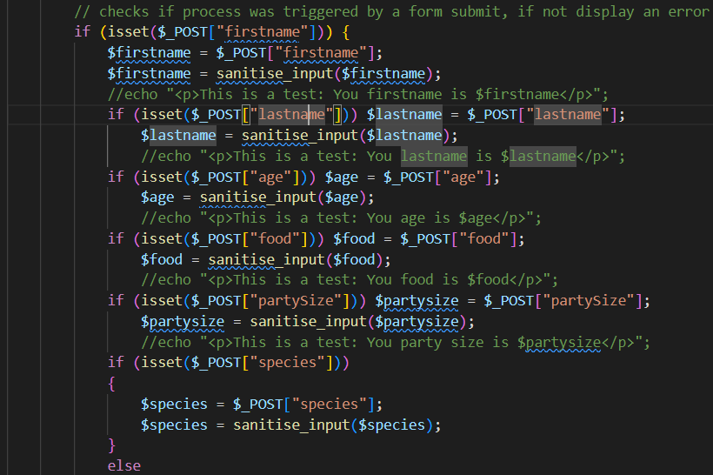
3. Text

   Description automatically generated

**Step 6:**

1. Text

   Description automatically generated with medium confidence
2. Text

   Description automatically generated

**Step 7:**

1. Graphical user interface, application

   Description automatically generated

[Link to web](https://mercury.swin.edu.au/cos10026/s103809048/lab08/register.html)